SE Project

Mow-E Technical Documentation

Raj Sakhrekar

Matr. Num.: 3259812

Nishanth Joseph Delavictoire

Matr. Num.: 3260057

Table of Contents

Mechanical Documentation 1

CAD Model: 1

CAD Renders 5

Electrical Documentation 7

Components 7

Block Diagram 15

Software Documentation 16

Arduino Uno Code 16

NodeMCU ESP8266 code 25

MOW-E.h code 39

WiFi_Settings.h code 42

Mow-E UI Desktop HTML/JS/CSS code 43

Mow-E UI S10e Altered CSS code 56

Mow-E UI S10e Altered HTML body code 61

# Mechanical Documentation

## CAD Model:

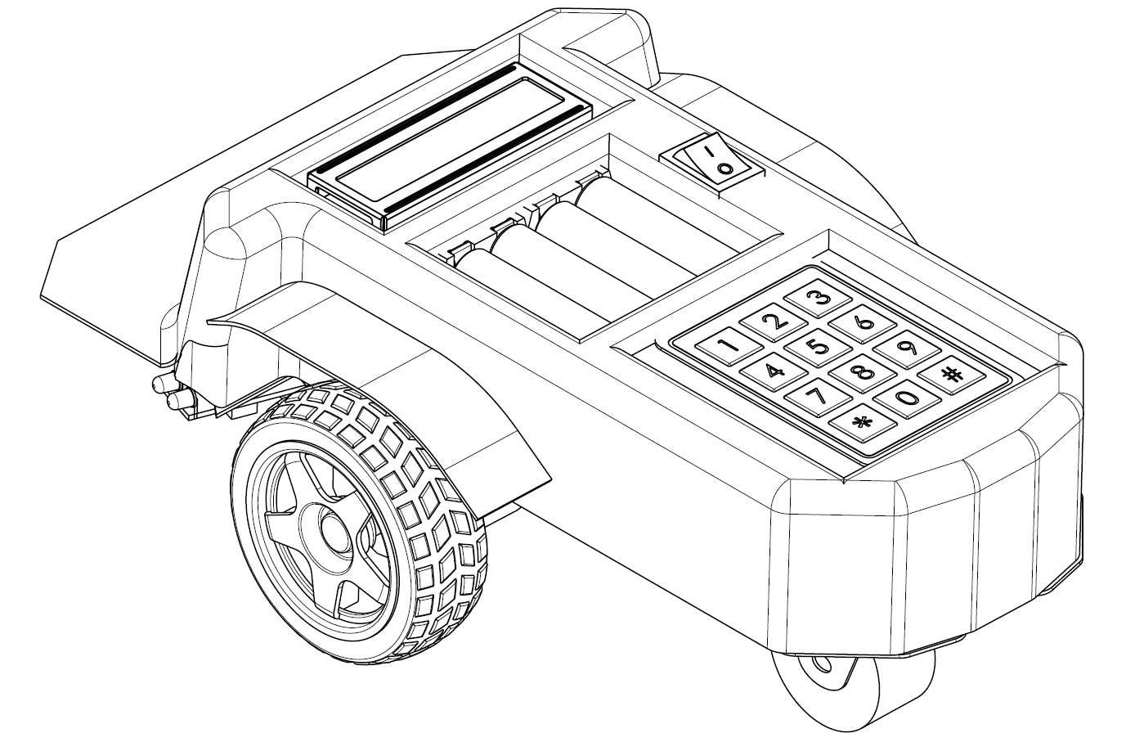

Isometric View

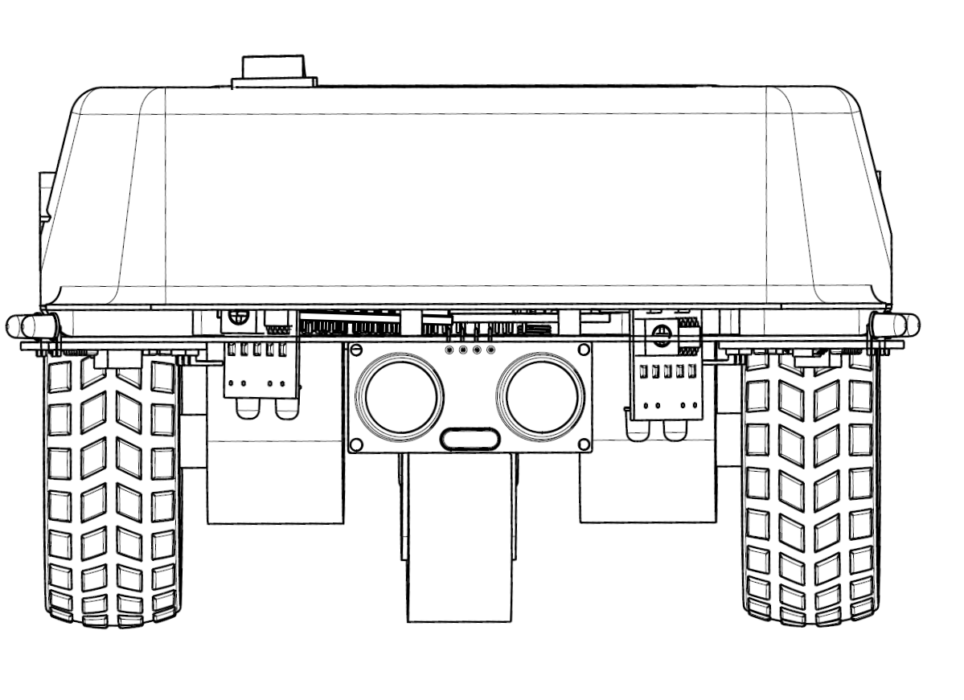

Front View

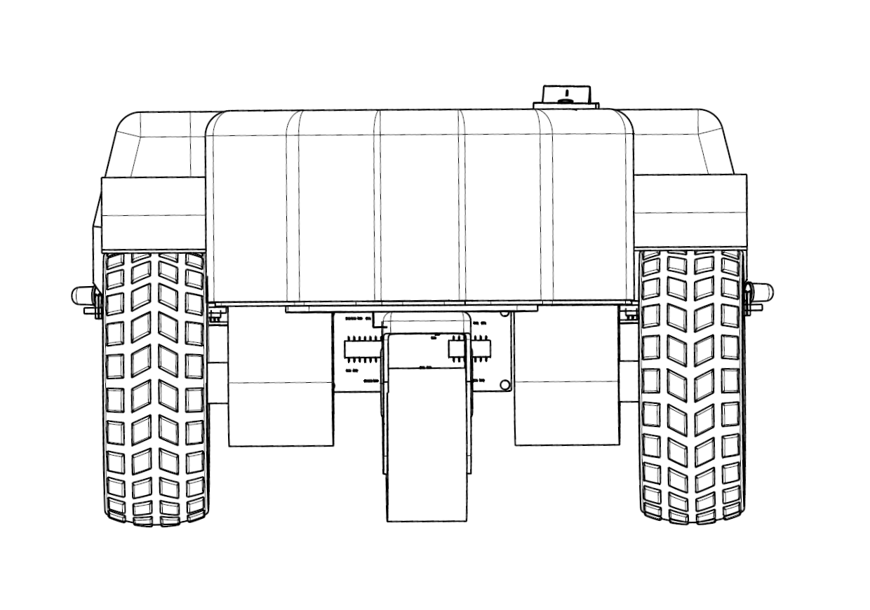

Rear View

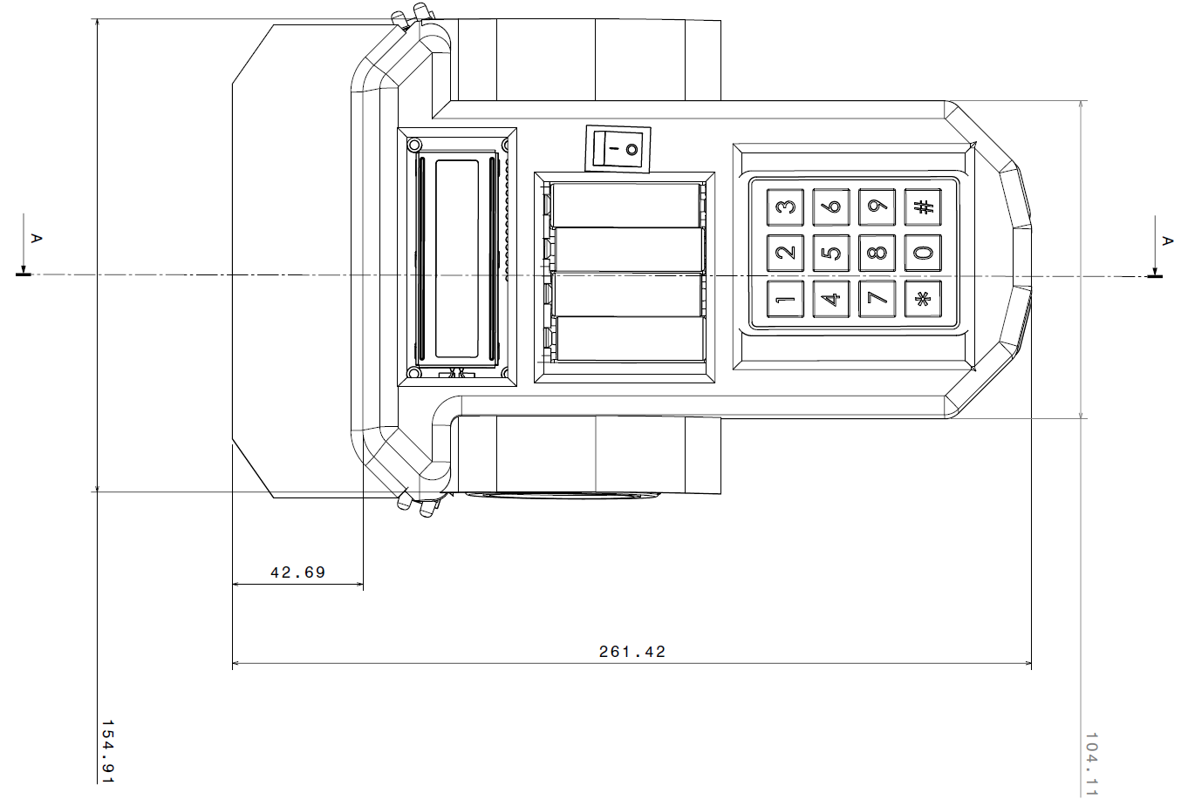

Top View

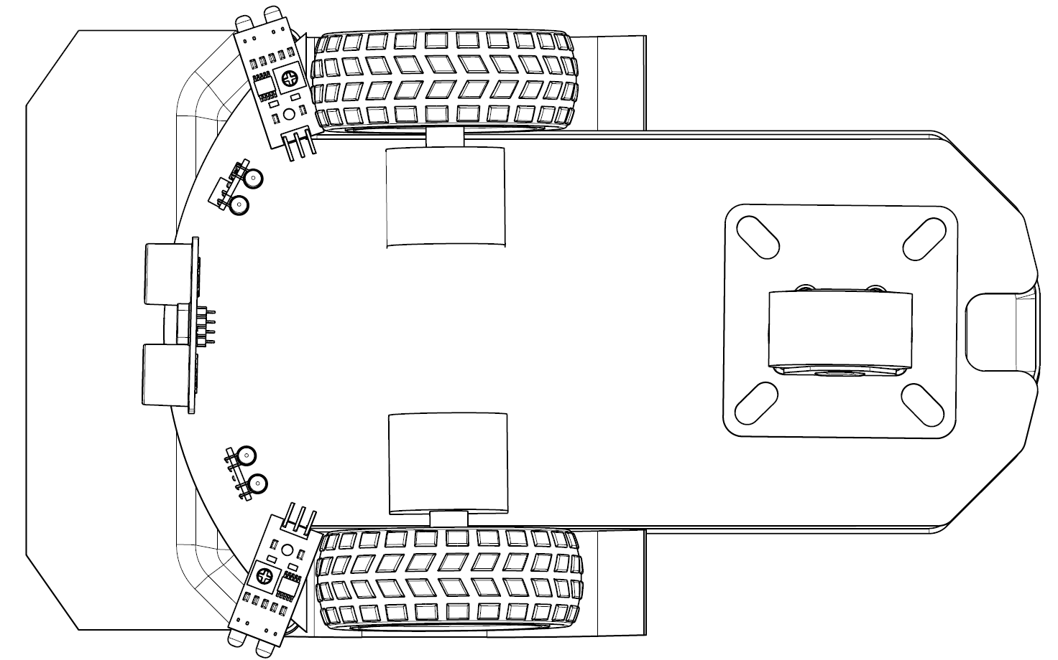

Bottom View

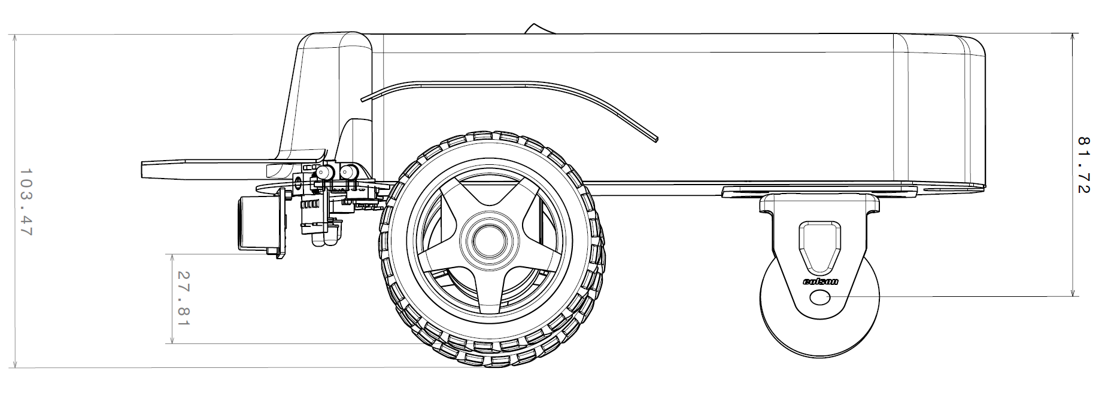

Side View

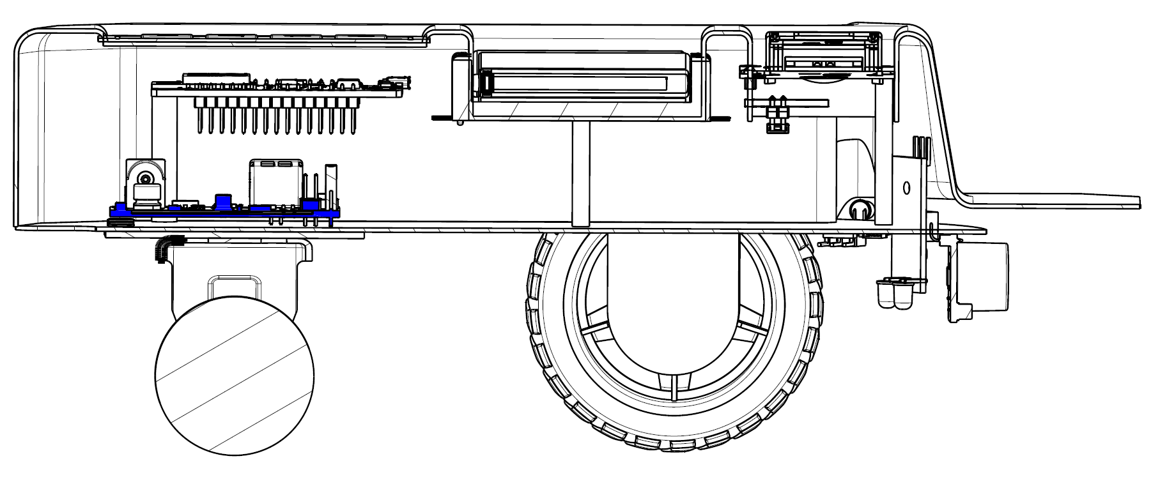

Section View A-A

CAD Renders:

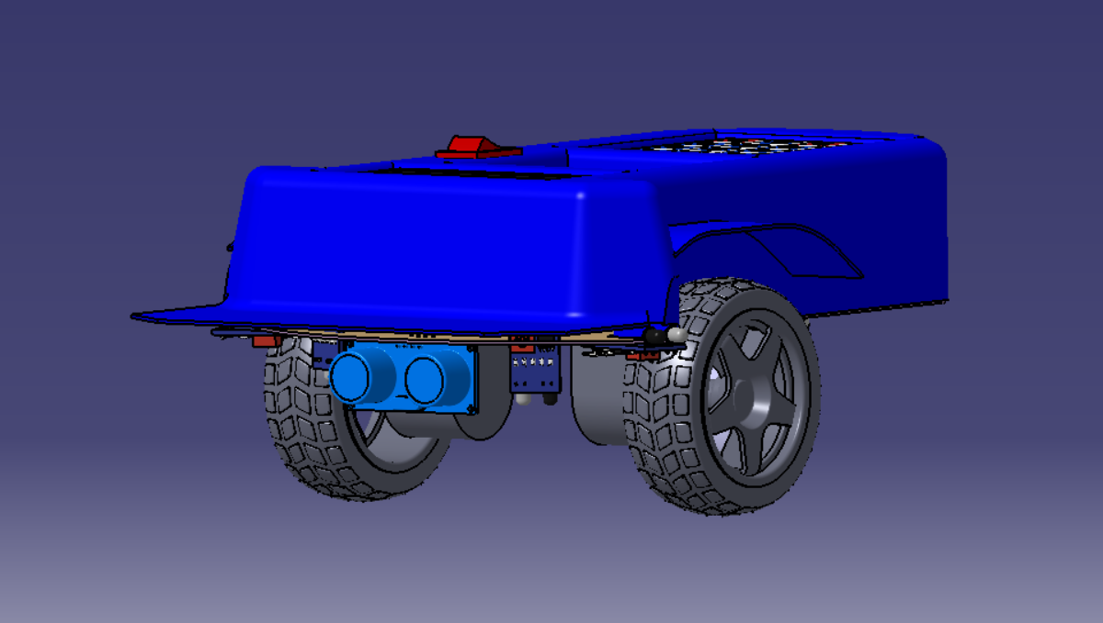

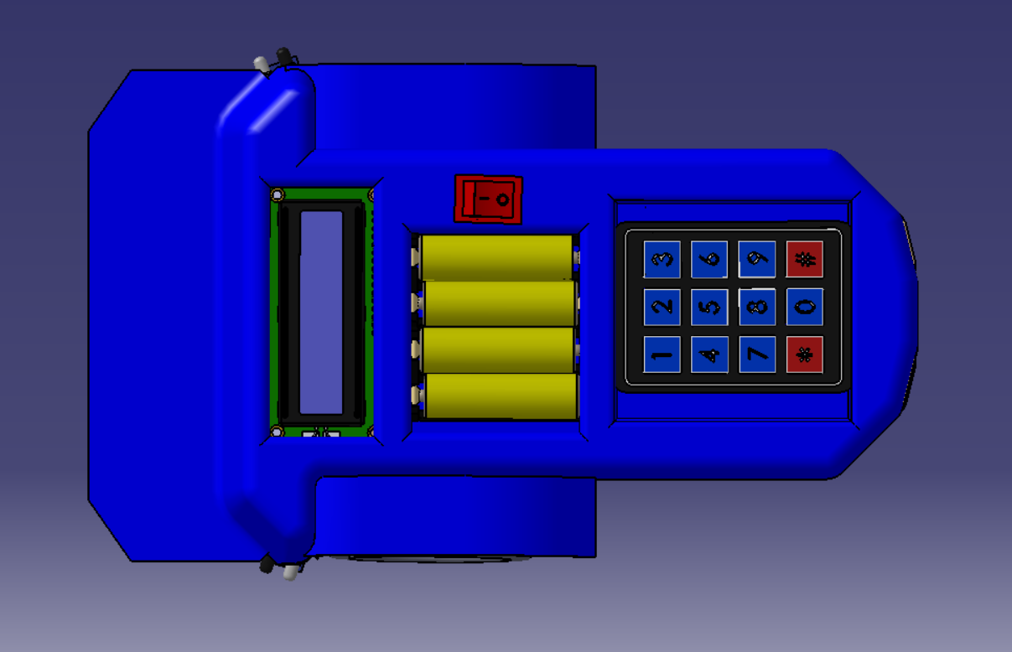

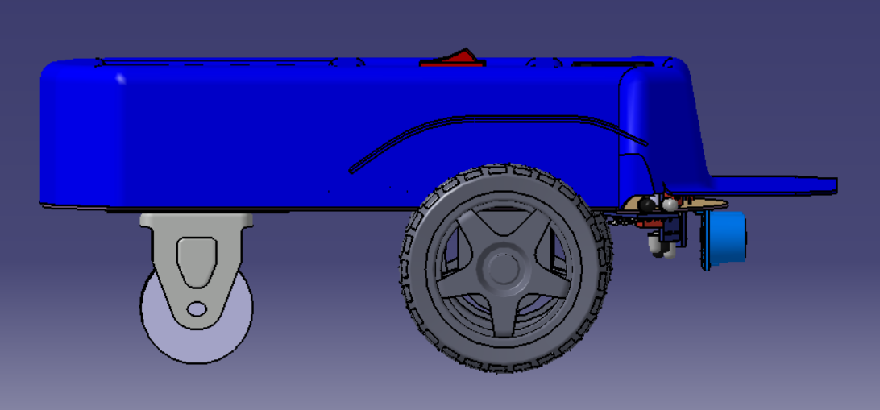

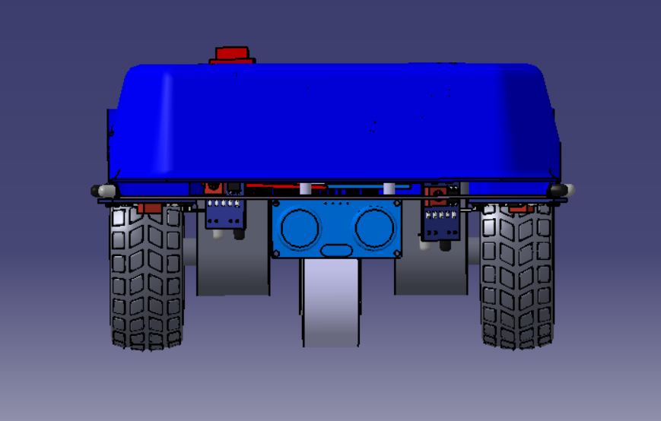

# Electrical Documentation

Components:

1. Arduino Uno:

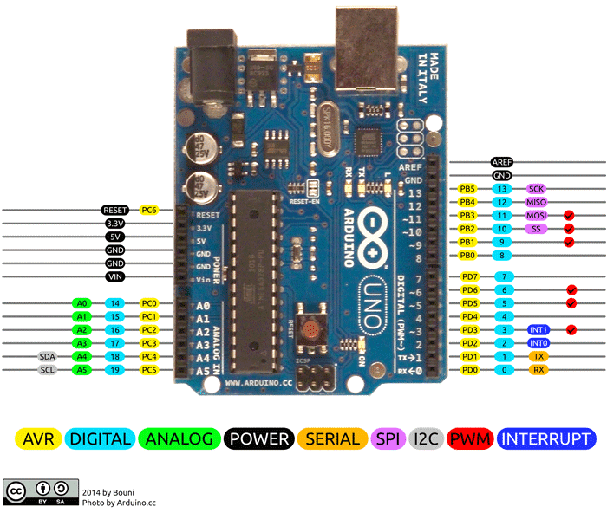

Pin Description-

|  |  |  |
| --- | --- | --- |
| Power | Vin, 3.3V, 5V, GND | Vin: Input voltage to Arduino when using an external power source.  5V: Regulated power supply used to power microcontroller and other components on the board.  3.3V: 3.3V supply generated by on-board voltage regulator. Maximum current draw is 50mA.  GND: ground pins. |
| Reset | Reset | Resets the microcontroller. |
| Analog Pins | A0 – A5 | Used to provide analog input in the range of 0-5V |
| I/O Pins | Digital Pins 0 - 13 | Can be used as input or output pins. |
| Serial | 0(Rx), 1(Tx) | Used to receive and transmit TTL serial data. |
| External Interrupts | 2, 3 | To trigger an interrupt. |
| PWM | 3, 5, 6, 9, 11 | Provides 8-bit PWM output. |
| SPI | 10 (SS), 11 (MOSI), 12 (MISO) and 13 (SCK) | Used for SPI communication. |
| Inbuilt LED | 13 | To turn on the inbuilt LED. |
| TWI | A4 (SDA), A5 (SCA) | Used for TWI communication. |
| AREF | AREF | To provide reference voltage for input voltage. |

Arduino Uno Technical Specifications-

|  |  |
| --- | --- |
| Microcontroller | [ATmega328P](https://components101.com/microcontrollers/atmega328p-pinout-features-datasheet) – 8-bit AVR family microcontroller |
| Operating Voltage | 5V |
| Recommended Input Voltage | 7-12V |
| Input Voltage Limits | 6-20V |
| Analog Input Pins | 6 (A0 – A5) |
| Digital I/O Pins | 14 (Out of which 6 provide PWM output) |
| DC Current on I/O Pins | 40 mA |
| DC Current on 3.3V Pin | 50 mA |
| Flash Memory | 32 KB (0.5 KB is used for Bootloader) |
| SRAM | 2 KB |
| EEPROM | 1 KB |
| Frequency (Clock Speed) | 16 MHz |

2. NodeMCU ESP8266:

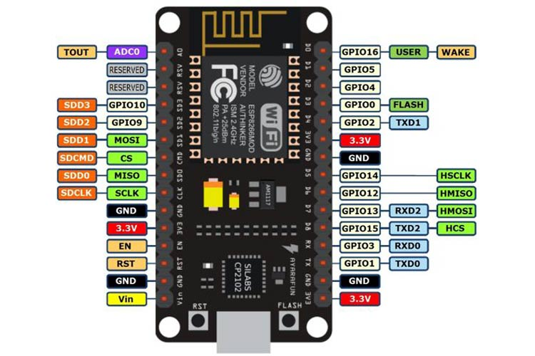

Pin Description-

|  |  |  |
| --- | --- | --- |
| Power | Micro-USB, 3.3V, GND, Vin | Micro-USB: NodeMCU can be powered through the USB port  3.3V: Regulated 3.3V can be supplied to this pin to power the board  GND: Ground pins  Vin: External Power Supply |
| Control Pins | **EN, RST** | The pin and the button resets the microcontroller |
| Analog Pin | A0 | Used to measure analog voltage in the range of 0-3.3V |
| GPIO Pins | GPIO1 to GPIO16 | NodeMCU has 16 general purpose input-output pins on its board |
| SPI Pins | SD1, CMD, SD0, CLK | NodeMCU has four pins available for SPI communication. |
| UART Pins | TXD0, RXD0, TXD2, RXD2 | NodeMCU has two UART interfaces, UART0 (RXD0 & TXD0) and UART1 (RXD1 & TXD1). UART1 is used to upload the firmware/program. |
| I2C Pins |  | NodeMCU has I2C functionality support but due to the internal functionality of these pins, you have to find which pin is I2C. |

ESP8266 Technical Specifications-

|  |  |
| --- | --- |
| Microcontroller | Tensilica 32-bit RISC CPU Xtensa LX106 |
| Operating Voltage | 3.3V |
| Input Voltage | 7-12V |
| Digital I/O Pins (DIO) | 16 |
| Analog Input Pins (ADC) | 1 |
| UARTs | 1 |
| SPIs | 1 |
| I2Cs | 1 |
| Flash Memory | 4 MB |
| SRAM | 64 KB |
| Clock Speed | 80 MHz |
| USB-TTL based on CP2102 is included onboard | Enables Plug n Play |
| PCB Antenna |  |

3. Arduino Uno Sensor Shield V5.0:

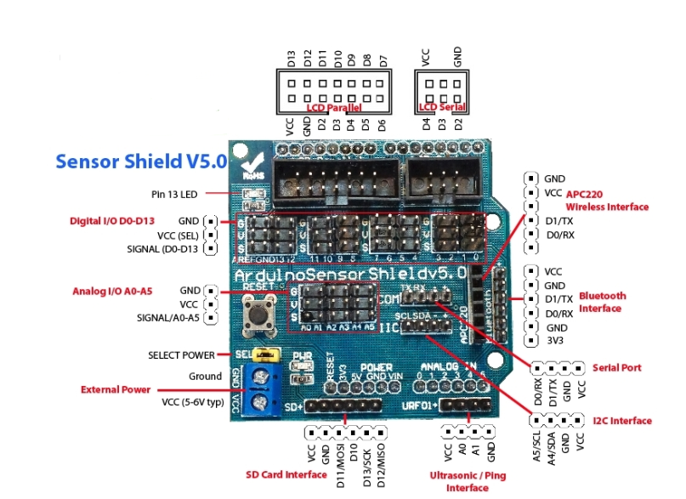

4. Motor Driver Module L298N:

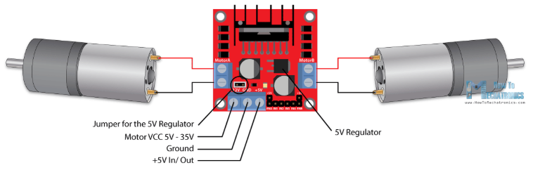

|  |  |
| --- | --- |
| IN1 & IN2 | Motor A input pins. Used to control the spinning direction of Motor A |
| IN3 & IN4 | Motor B input pins. Used to control the spinning direction of Motor B |
| ENA | Enables PWM signal for Motor A |
| ENB | Enables PWM signal for Motor B |
| OUT1 & OUT2 | Output pins of Motor A |
| OUT3 & OUT4 | Output pins of Motor B |
| 12V | 12V input from DC power Source |
| 5V | Supplies power for the switching logic circuitry inside L298N IC |
| GND | Ground pin |

|  |  |
| --- | --- |
| Driver Model | L298N 2A |
| Driver Chip | Double H Bridge L298N |
| Motor Supply Voltage (Maximum) | 46V |
| Motor Supply Current (Maximum) | 2A |
| Logic Voltage | 5V |
| Driver Voltage | 5-35V |
| Driver Current | 2A |
| Logical Current | 0-36mA |
| Maximum Power (W) | 25W |

5. Ultrasonic Sensor HC-SR04:

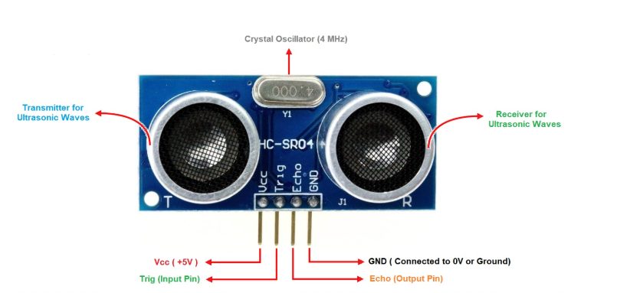

|  |  |
| --- | --- |
| Trigger | Trigger pin is an Input pin. This pin has to be kept high for 10us to initialize measurement by sending US wave. |
| Echo | Echo pin is an Output pin. This pin goes high for a period of time which will be equal to the time taken for the US wave to return back to the sensor. |
| Operating voltage | +5V |
| Theoretical  Measuring Distance | 2cm to 450cm |
| Practical Measuring Distance | 2cm to 80cm |
| Accuracy | 3mm |
| Measuring angle covered | <15° |
| Operating Current | <15mA |
| Operating Frequency | 40Hz |

6. Infrared Sensor:

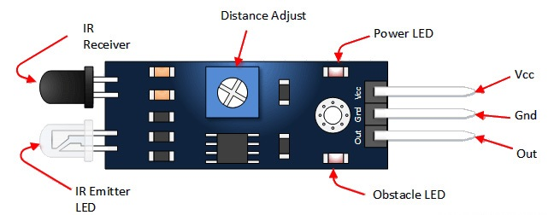

|  |  |
| --- | --- |
| Operating voltage | 5VDC |
| I/O pins compliance | 5V and 3.3V |
| Range | Up to 20cm |
| supply current | 20mA |

7. 4x4 Keypad:

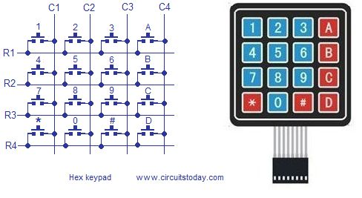

|  |  |
| --- | --- |
| Maximum Voltage across EACH SEGMENT or BUTTON | 24V |
| Maximum Current through  EACH SEGMENT or BUTTON | 30mA |
| Maximum operating temperature | 0°C to + 50°C |

8. 16x2 I2C LCD:

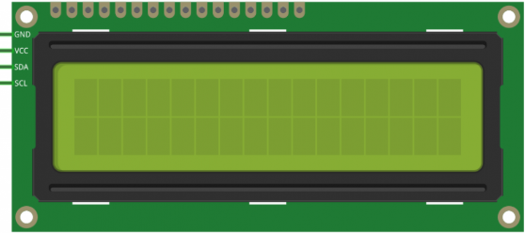

9. Battery pack:

|  |  |
| --- | --- |
| Batteries used | Duracell Duralock rechargeable AA batteries |
| Quantity | 4 |
| Capacity per battery | 2500mAh |
| Voltage per battery | 1.2V |

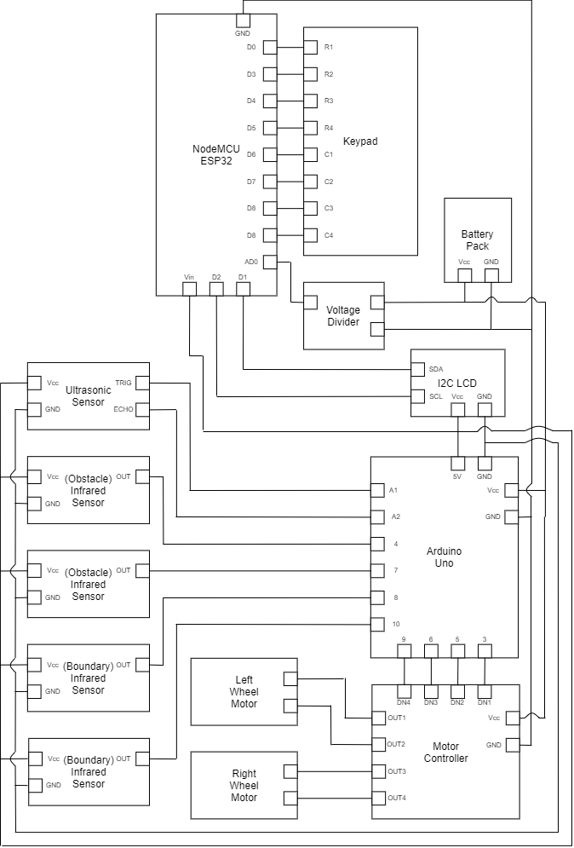Block Diagram:

# Software Documentation

Arduino Uno Code:

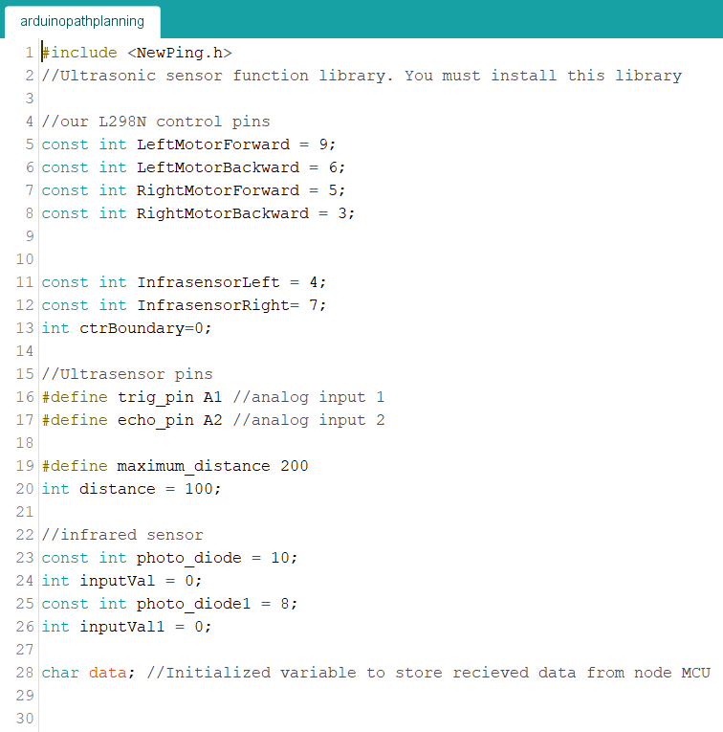

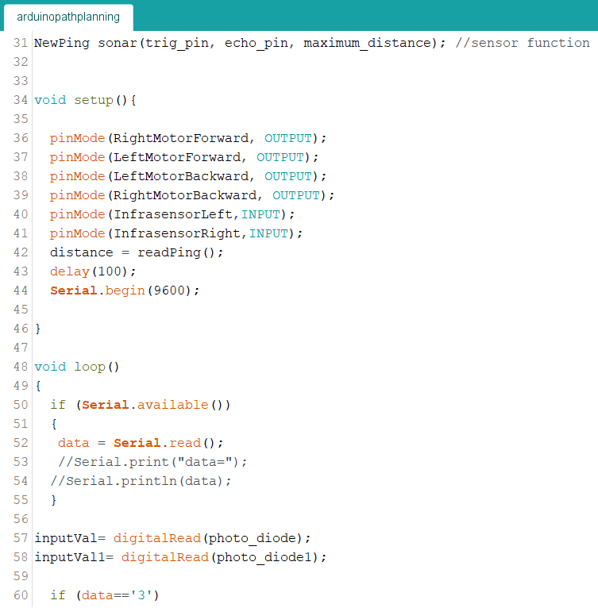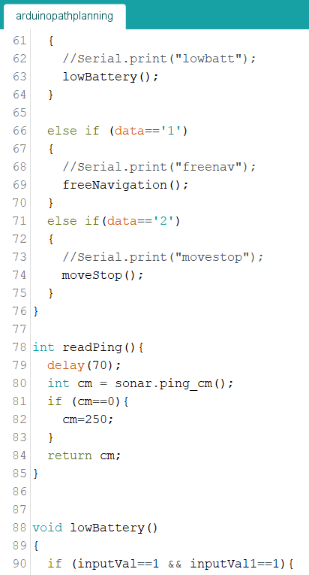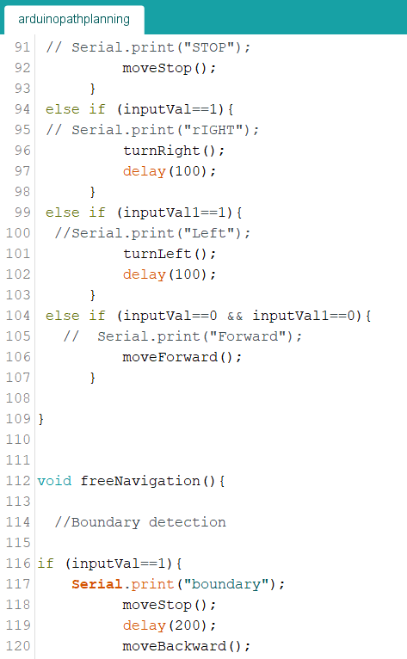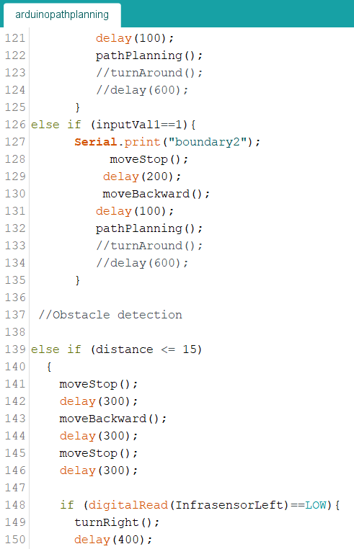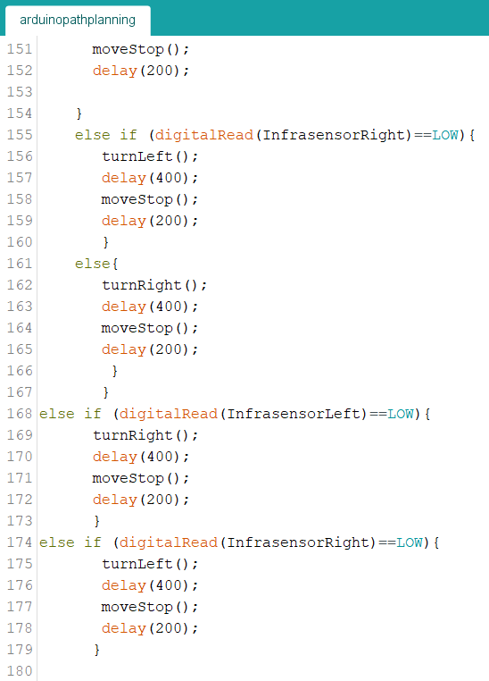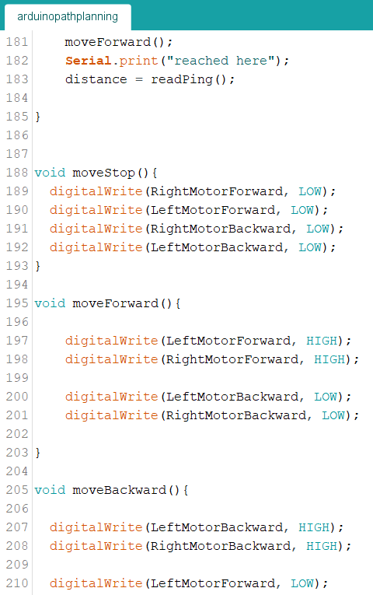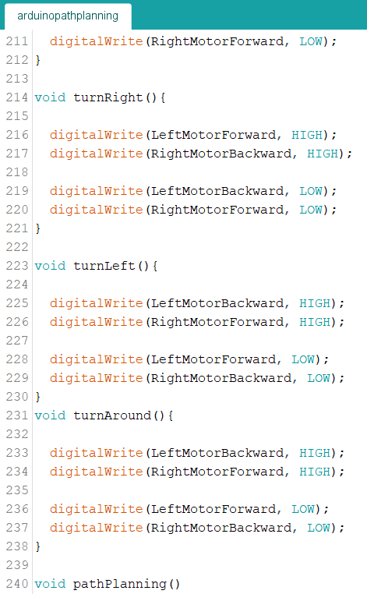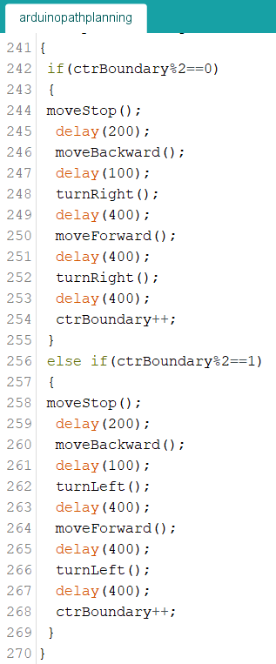

NodeMCU ESP8266 code:

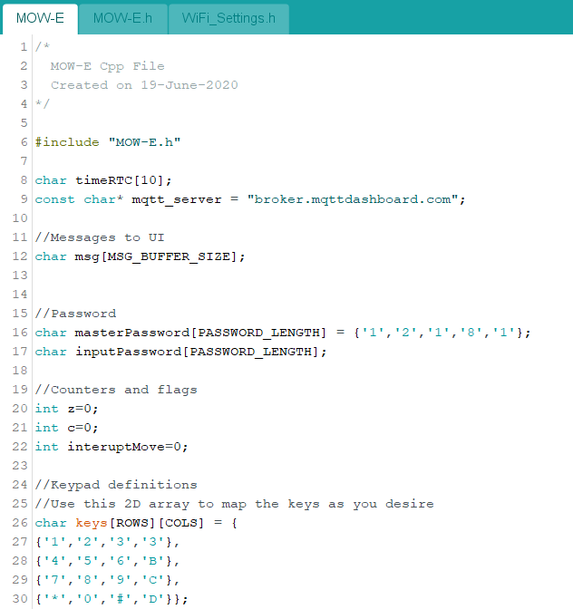

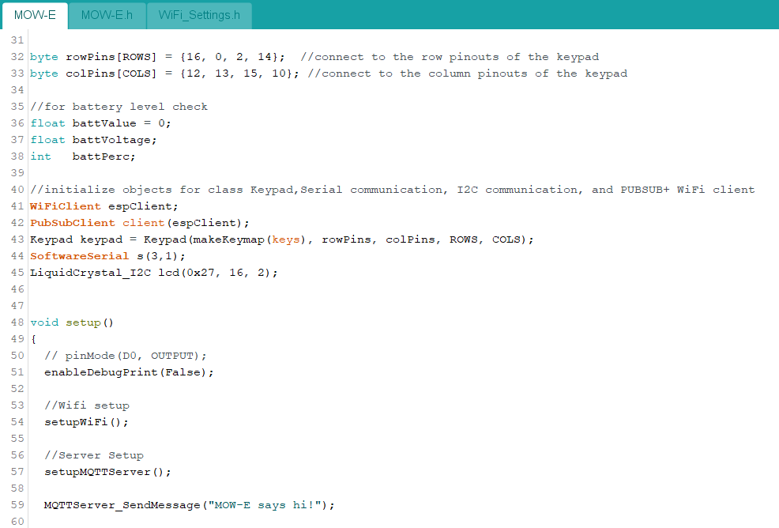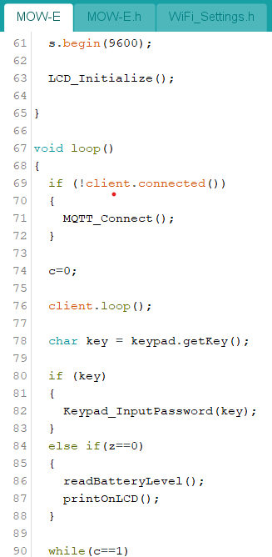

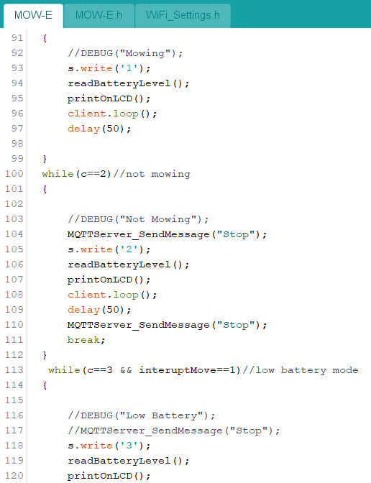

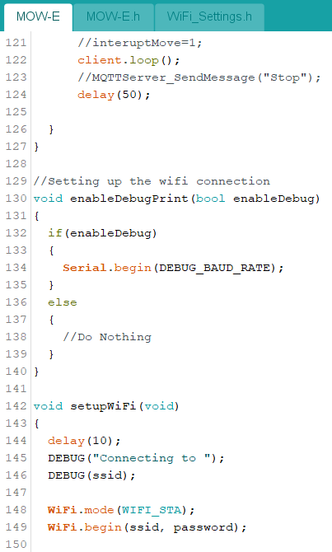

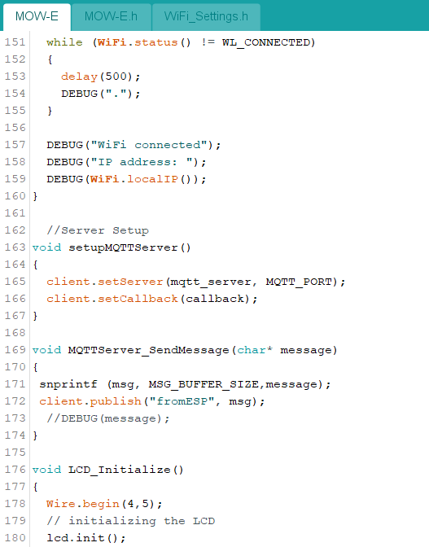

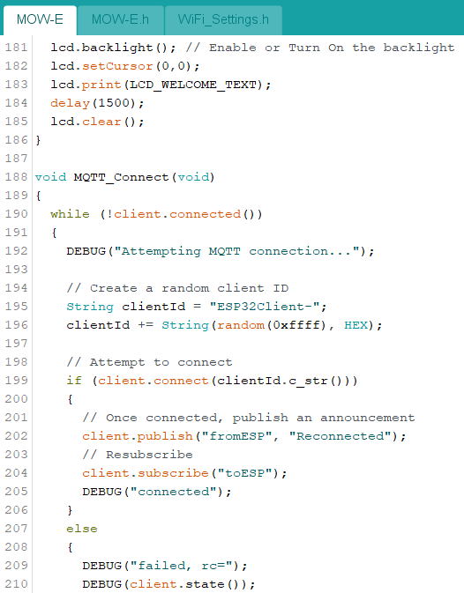

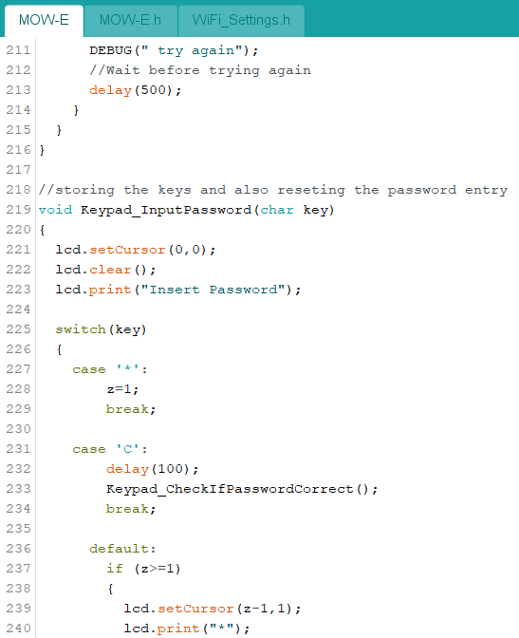

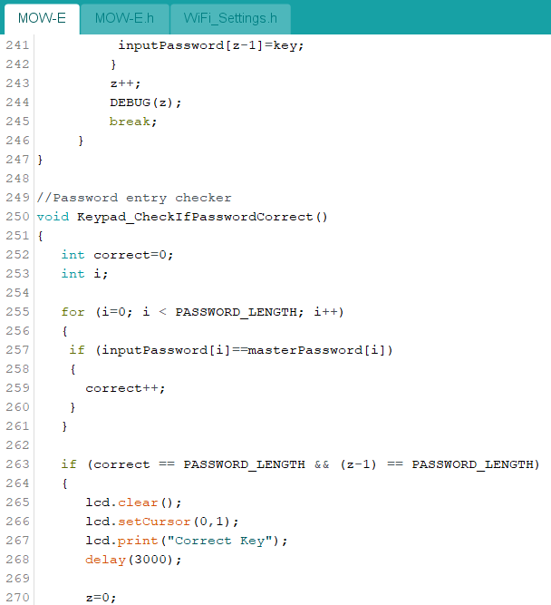

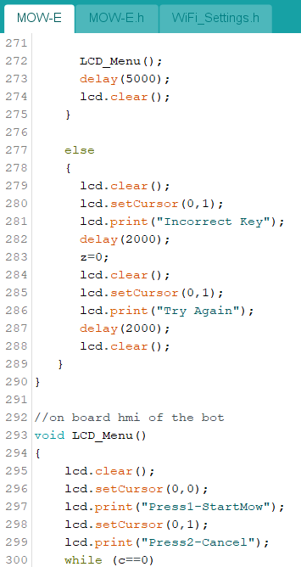

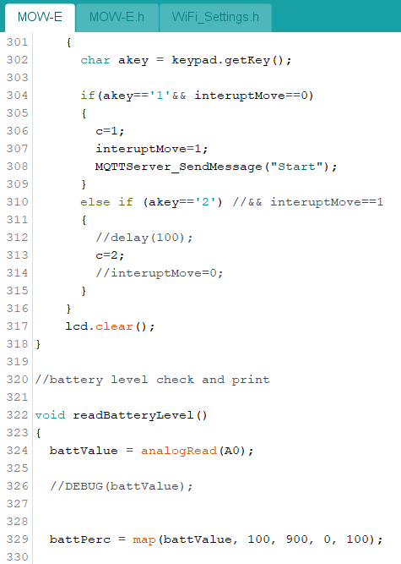

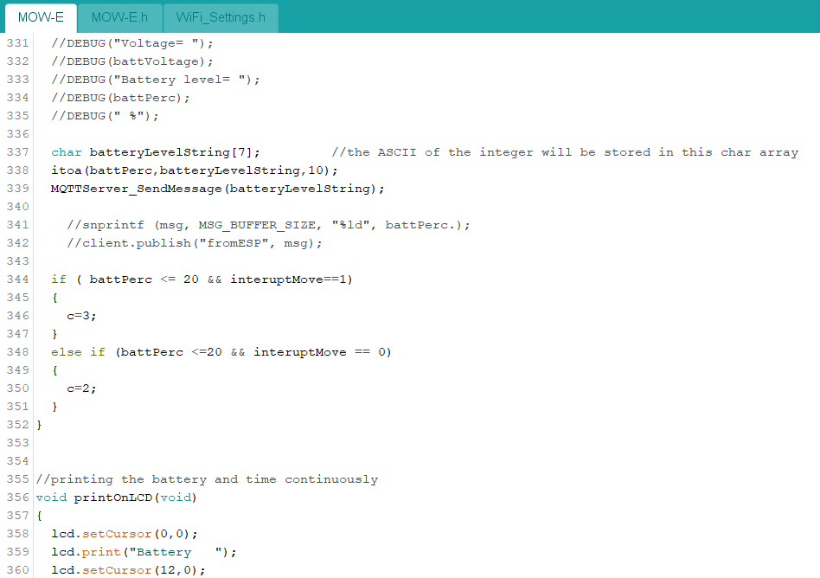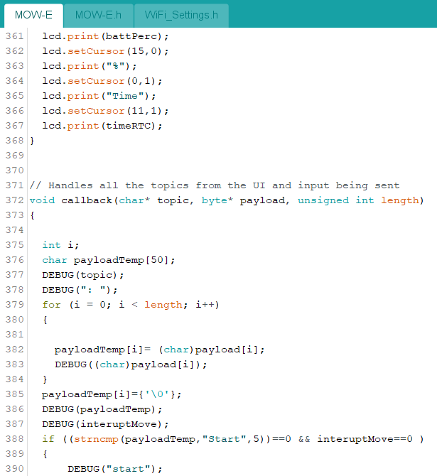

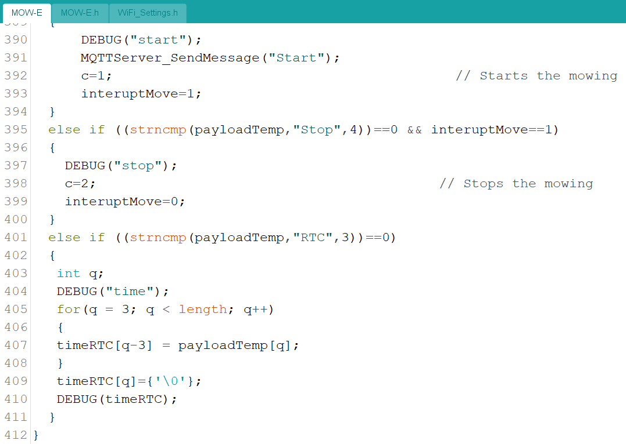

MOW-E.h code:

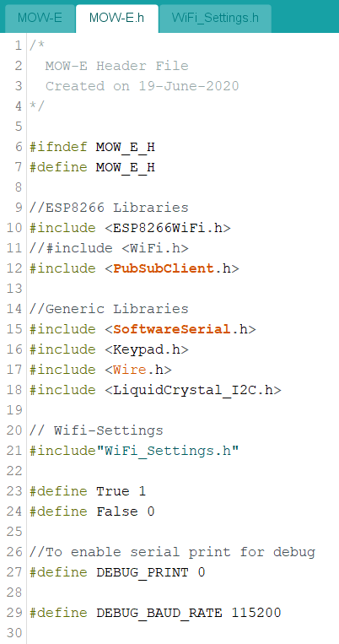

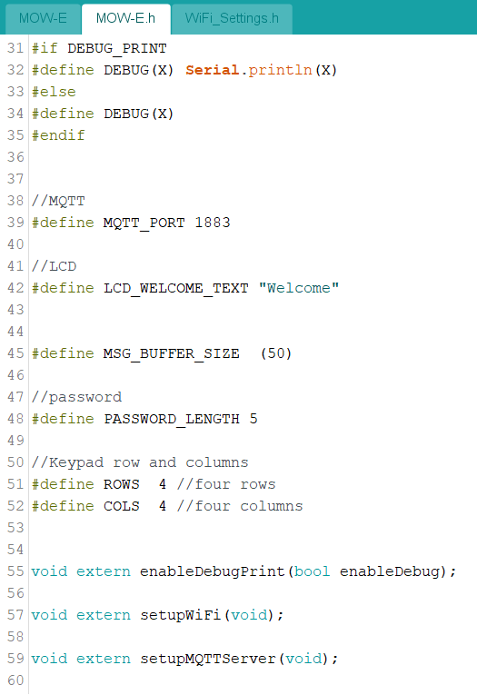

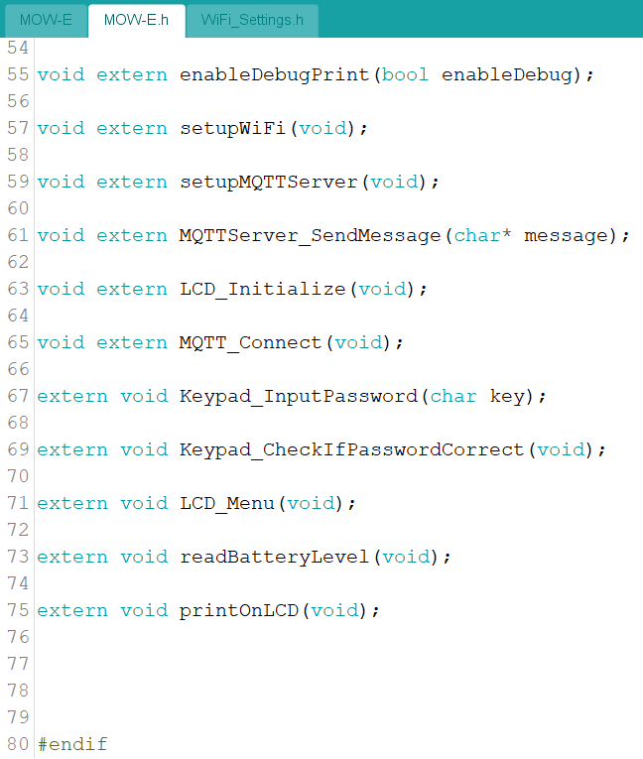

WiFi_Settings.h code:

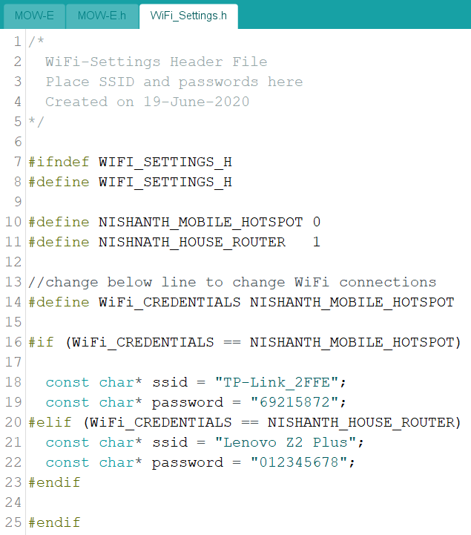

Mow-E UI Desktop HTML/JS/CSS code:

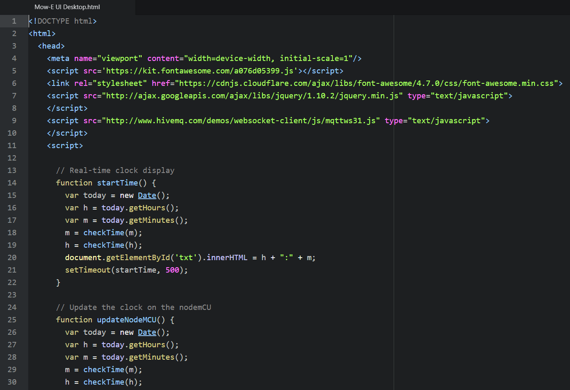

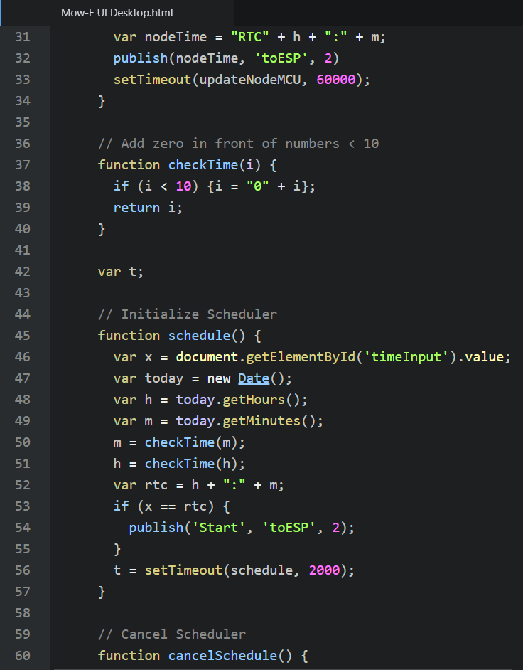

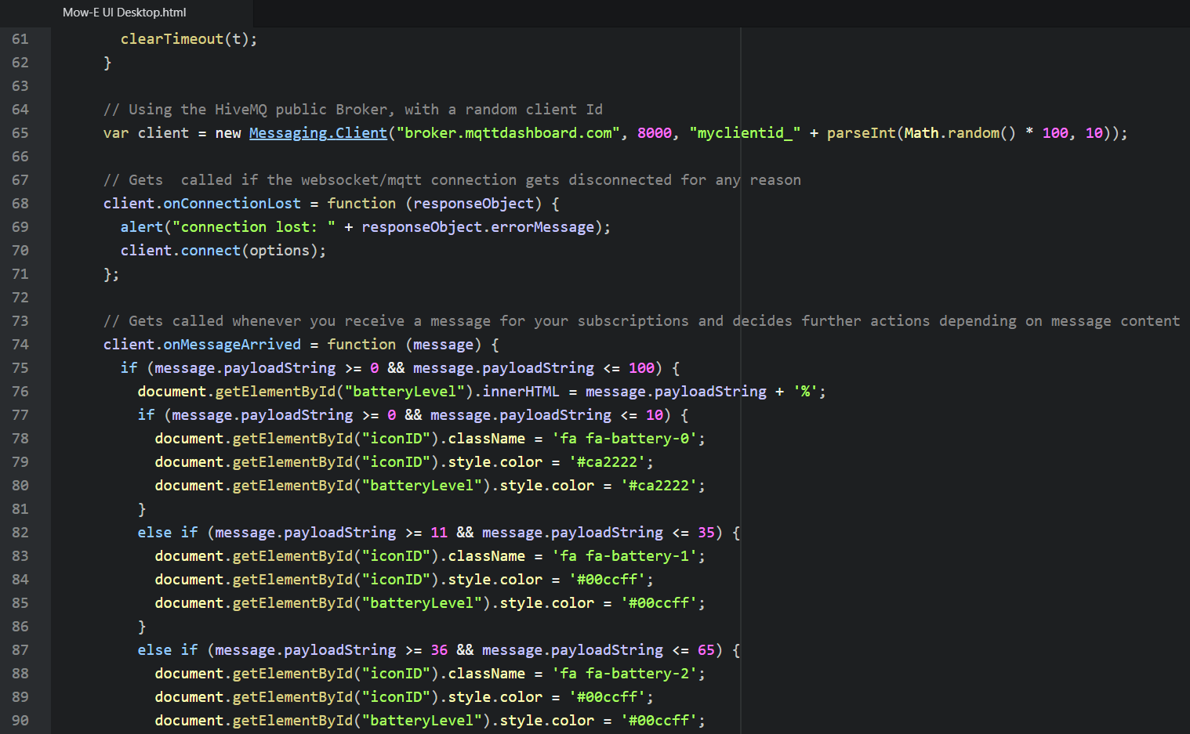

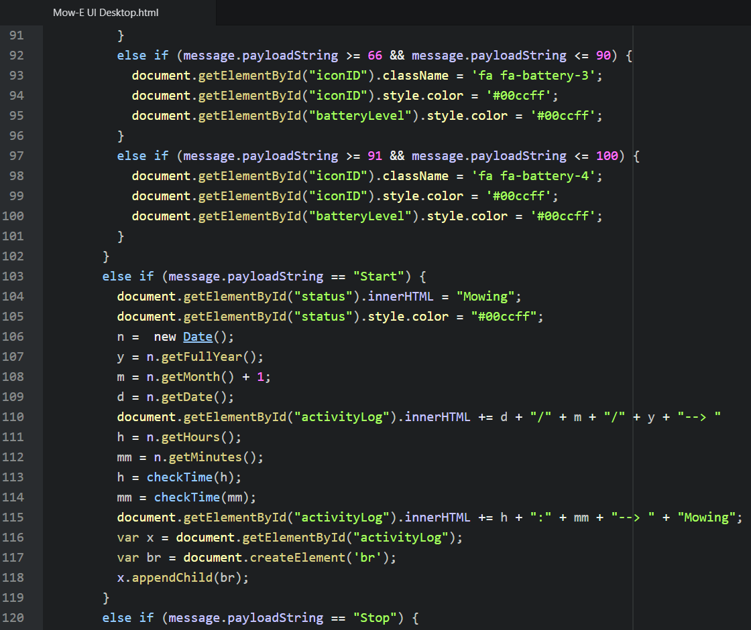

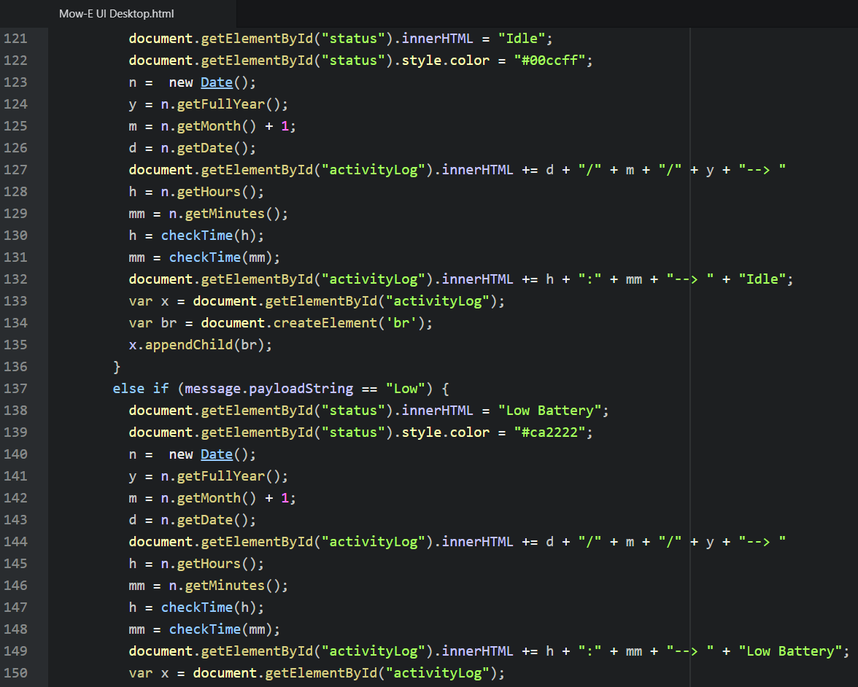

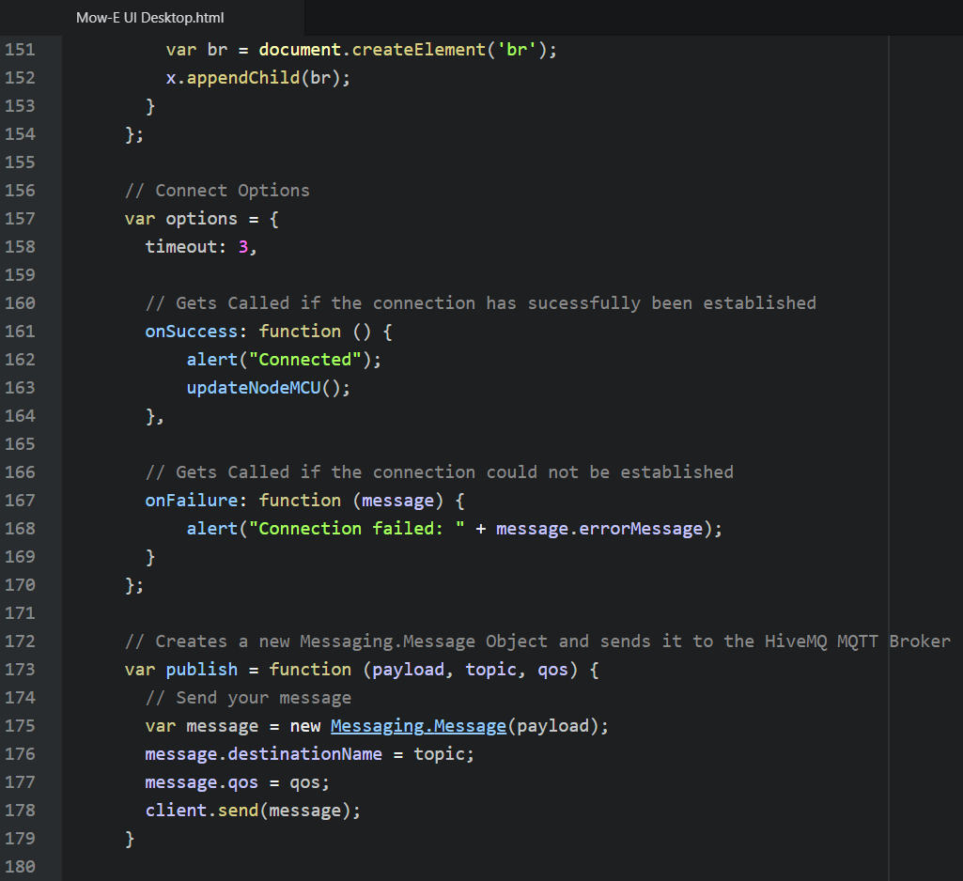

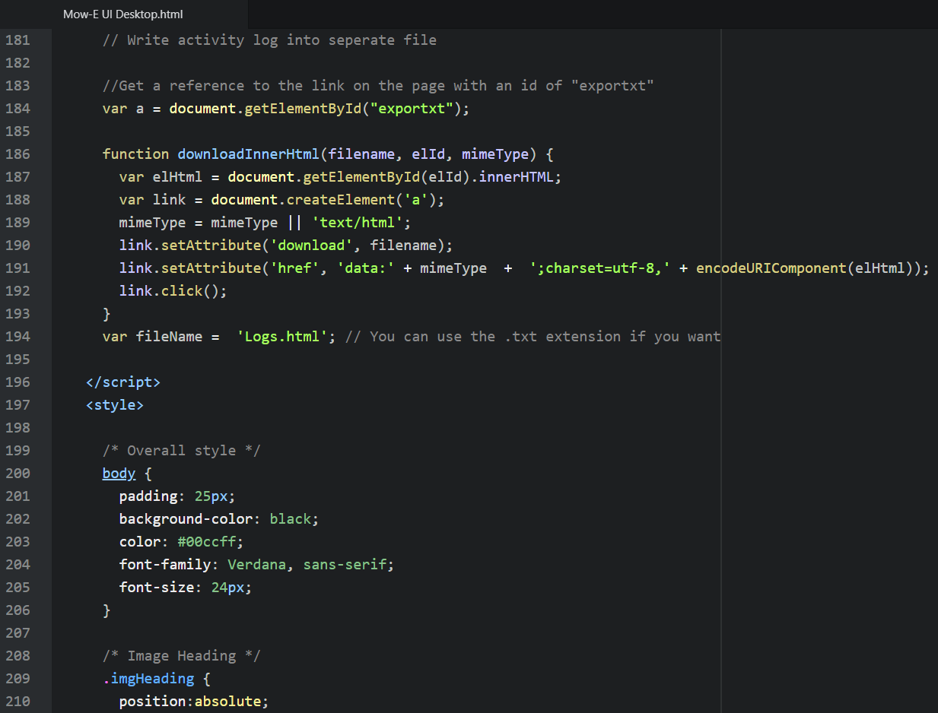

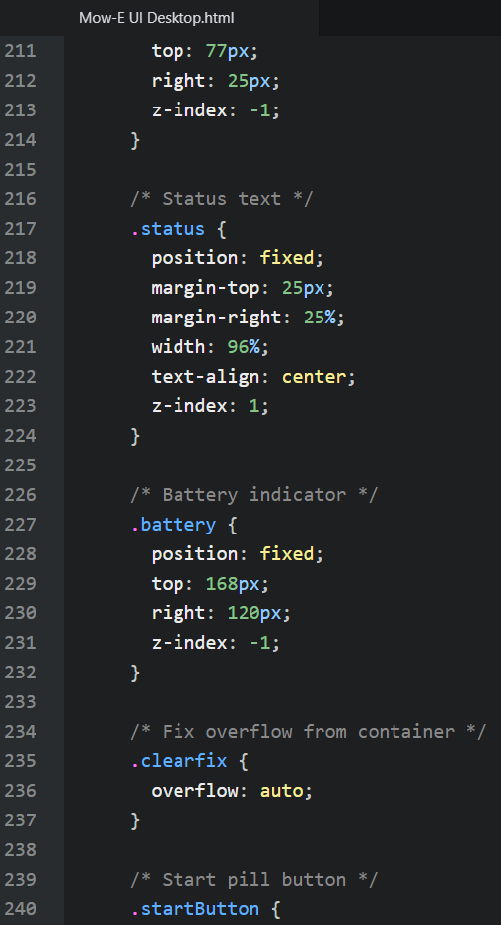

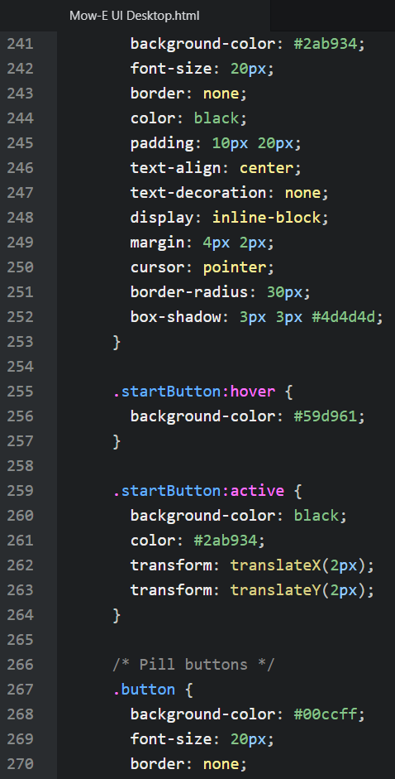

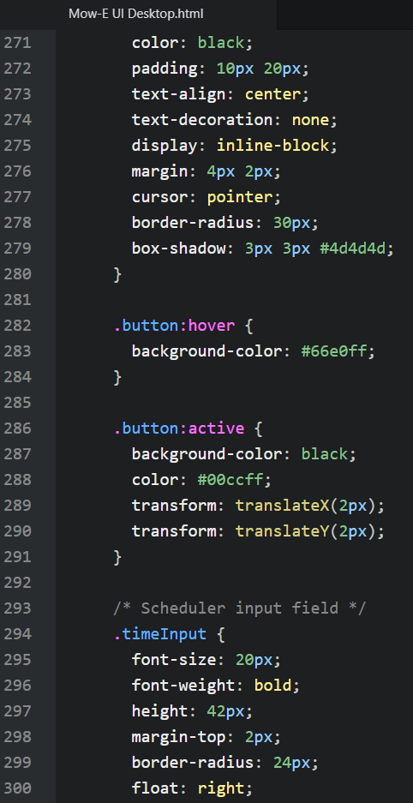

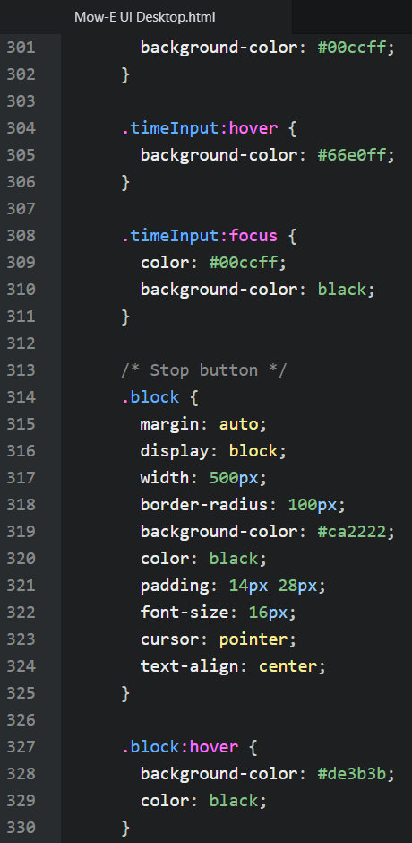

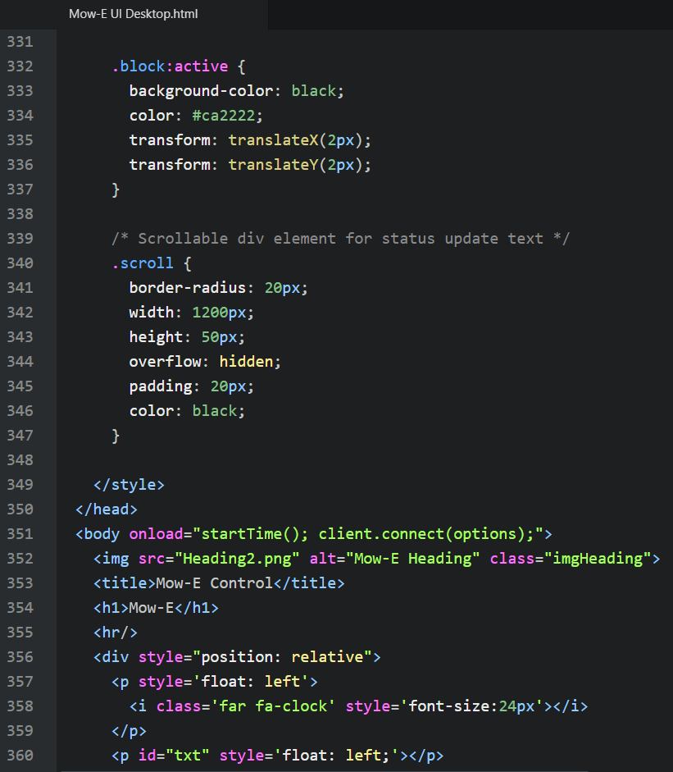

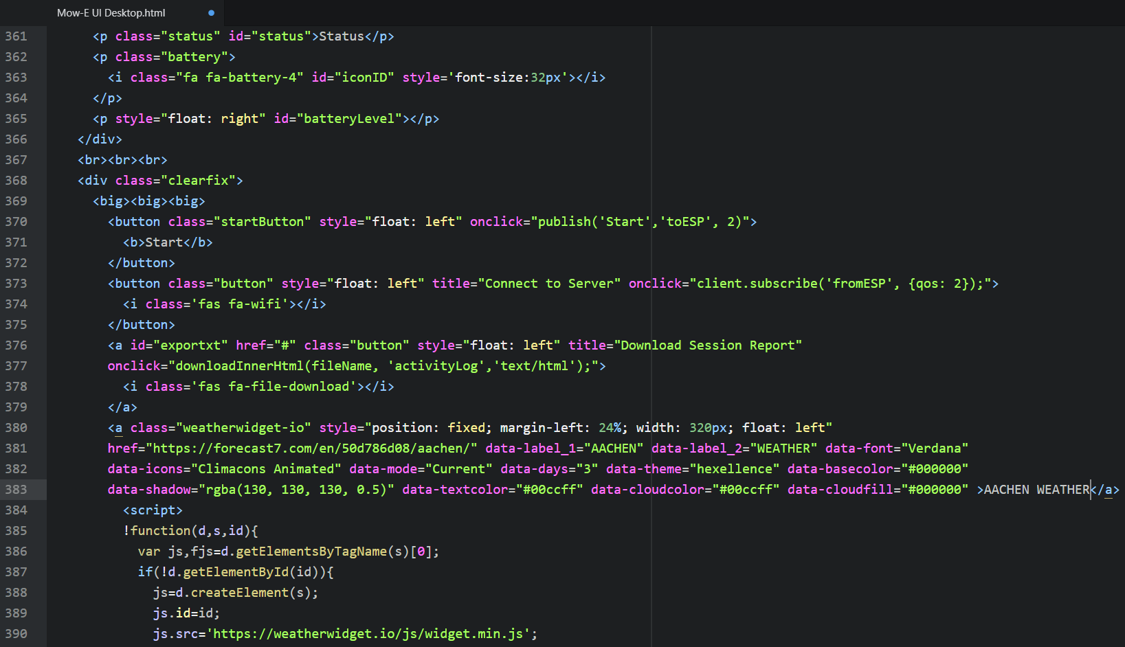

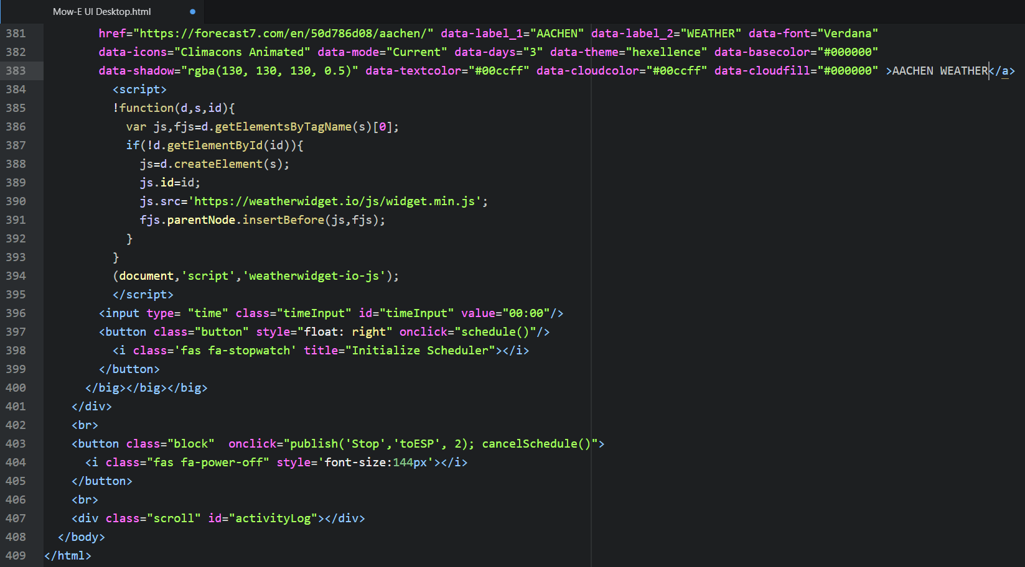

Mow-E UI S10e Altered CSS code:

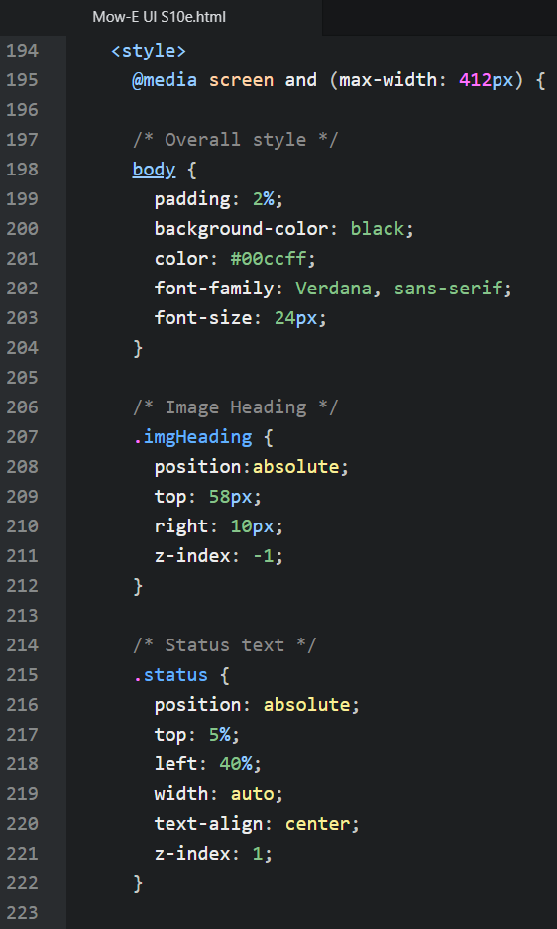

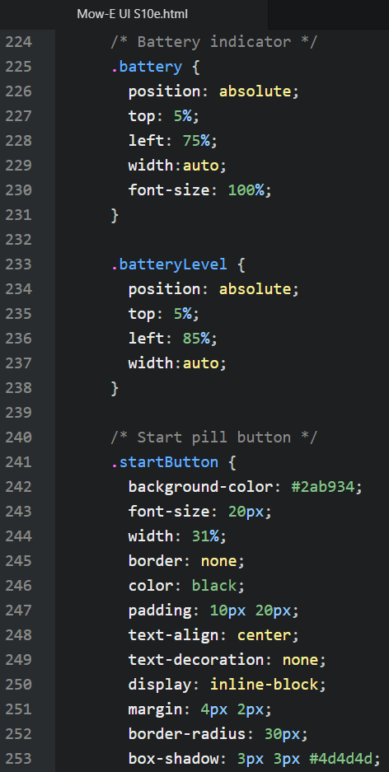

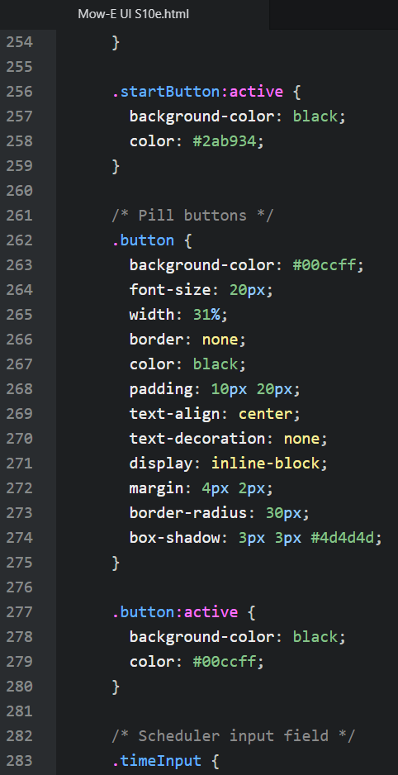

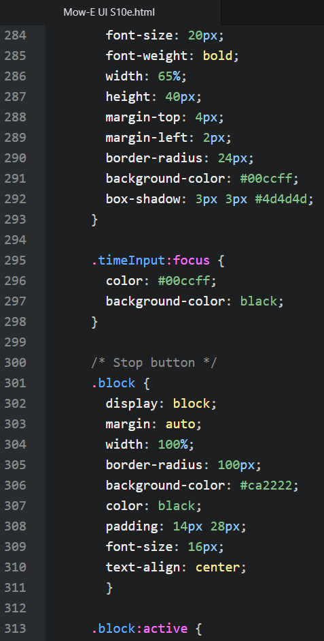

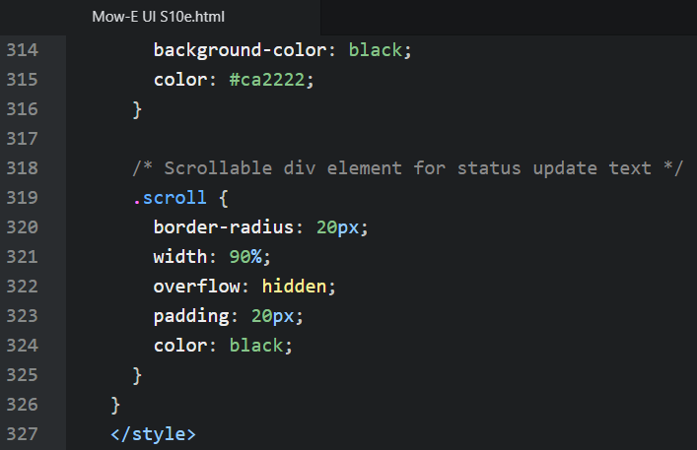

Mow-E UI S10e Altered HTML body code:

